Join the First Steps Family!

Regular giving ensures that young children living in areas of high need receive the best start in life. This reverses the cycle of poverty in our local community.

£12 funds hot nutritious meals and snacks for four days for one young child whose family are managing on a low income
£20 Pays for a young child to join in with an inspiring additional activity for five-six weeks, such as Rugby Tots
£40 Early years therapeutic activity for children with special educational needs

Please help us improve outcomes for children and sign up to a monthly donation. You can do this by:
- setting up a standing order by completing the form overleaf
- donating through payroll giving at your workplace
- setting up your own monthly bank transfer - our bank details are:
Nat West Bank plc, 39 Milsom Street, Bath BA1 1DS
Donation Account No: 50871722 Sort Code: 60-02-05

If you are a UK tax-payer, you can increase the value of your gift to First Steps Bath by completing the Gift Aid declaration overleaf when you donate. Your donation will then be increased by 25p in tax back for every £1 that you donate. Please complete the form overleaf to enable First Steps to claim the Gift Aid.

www.firststepsbath.org.uk 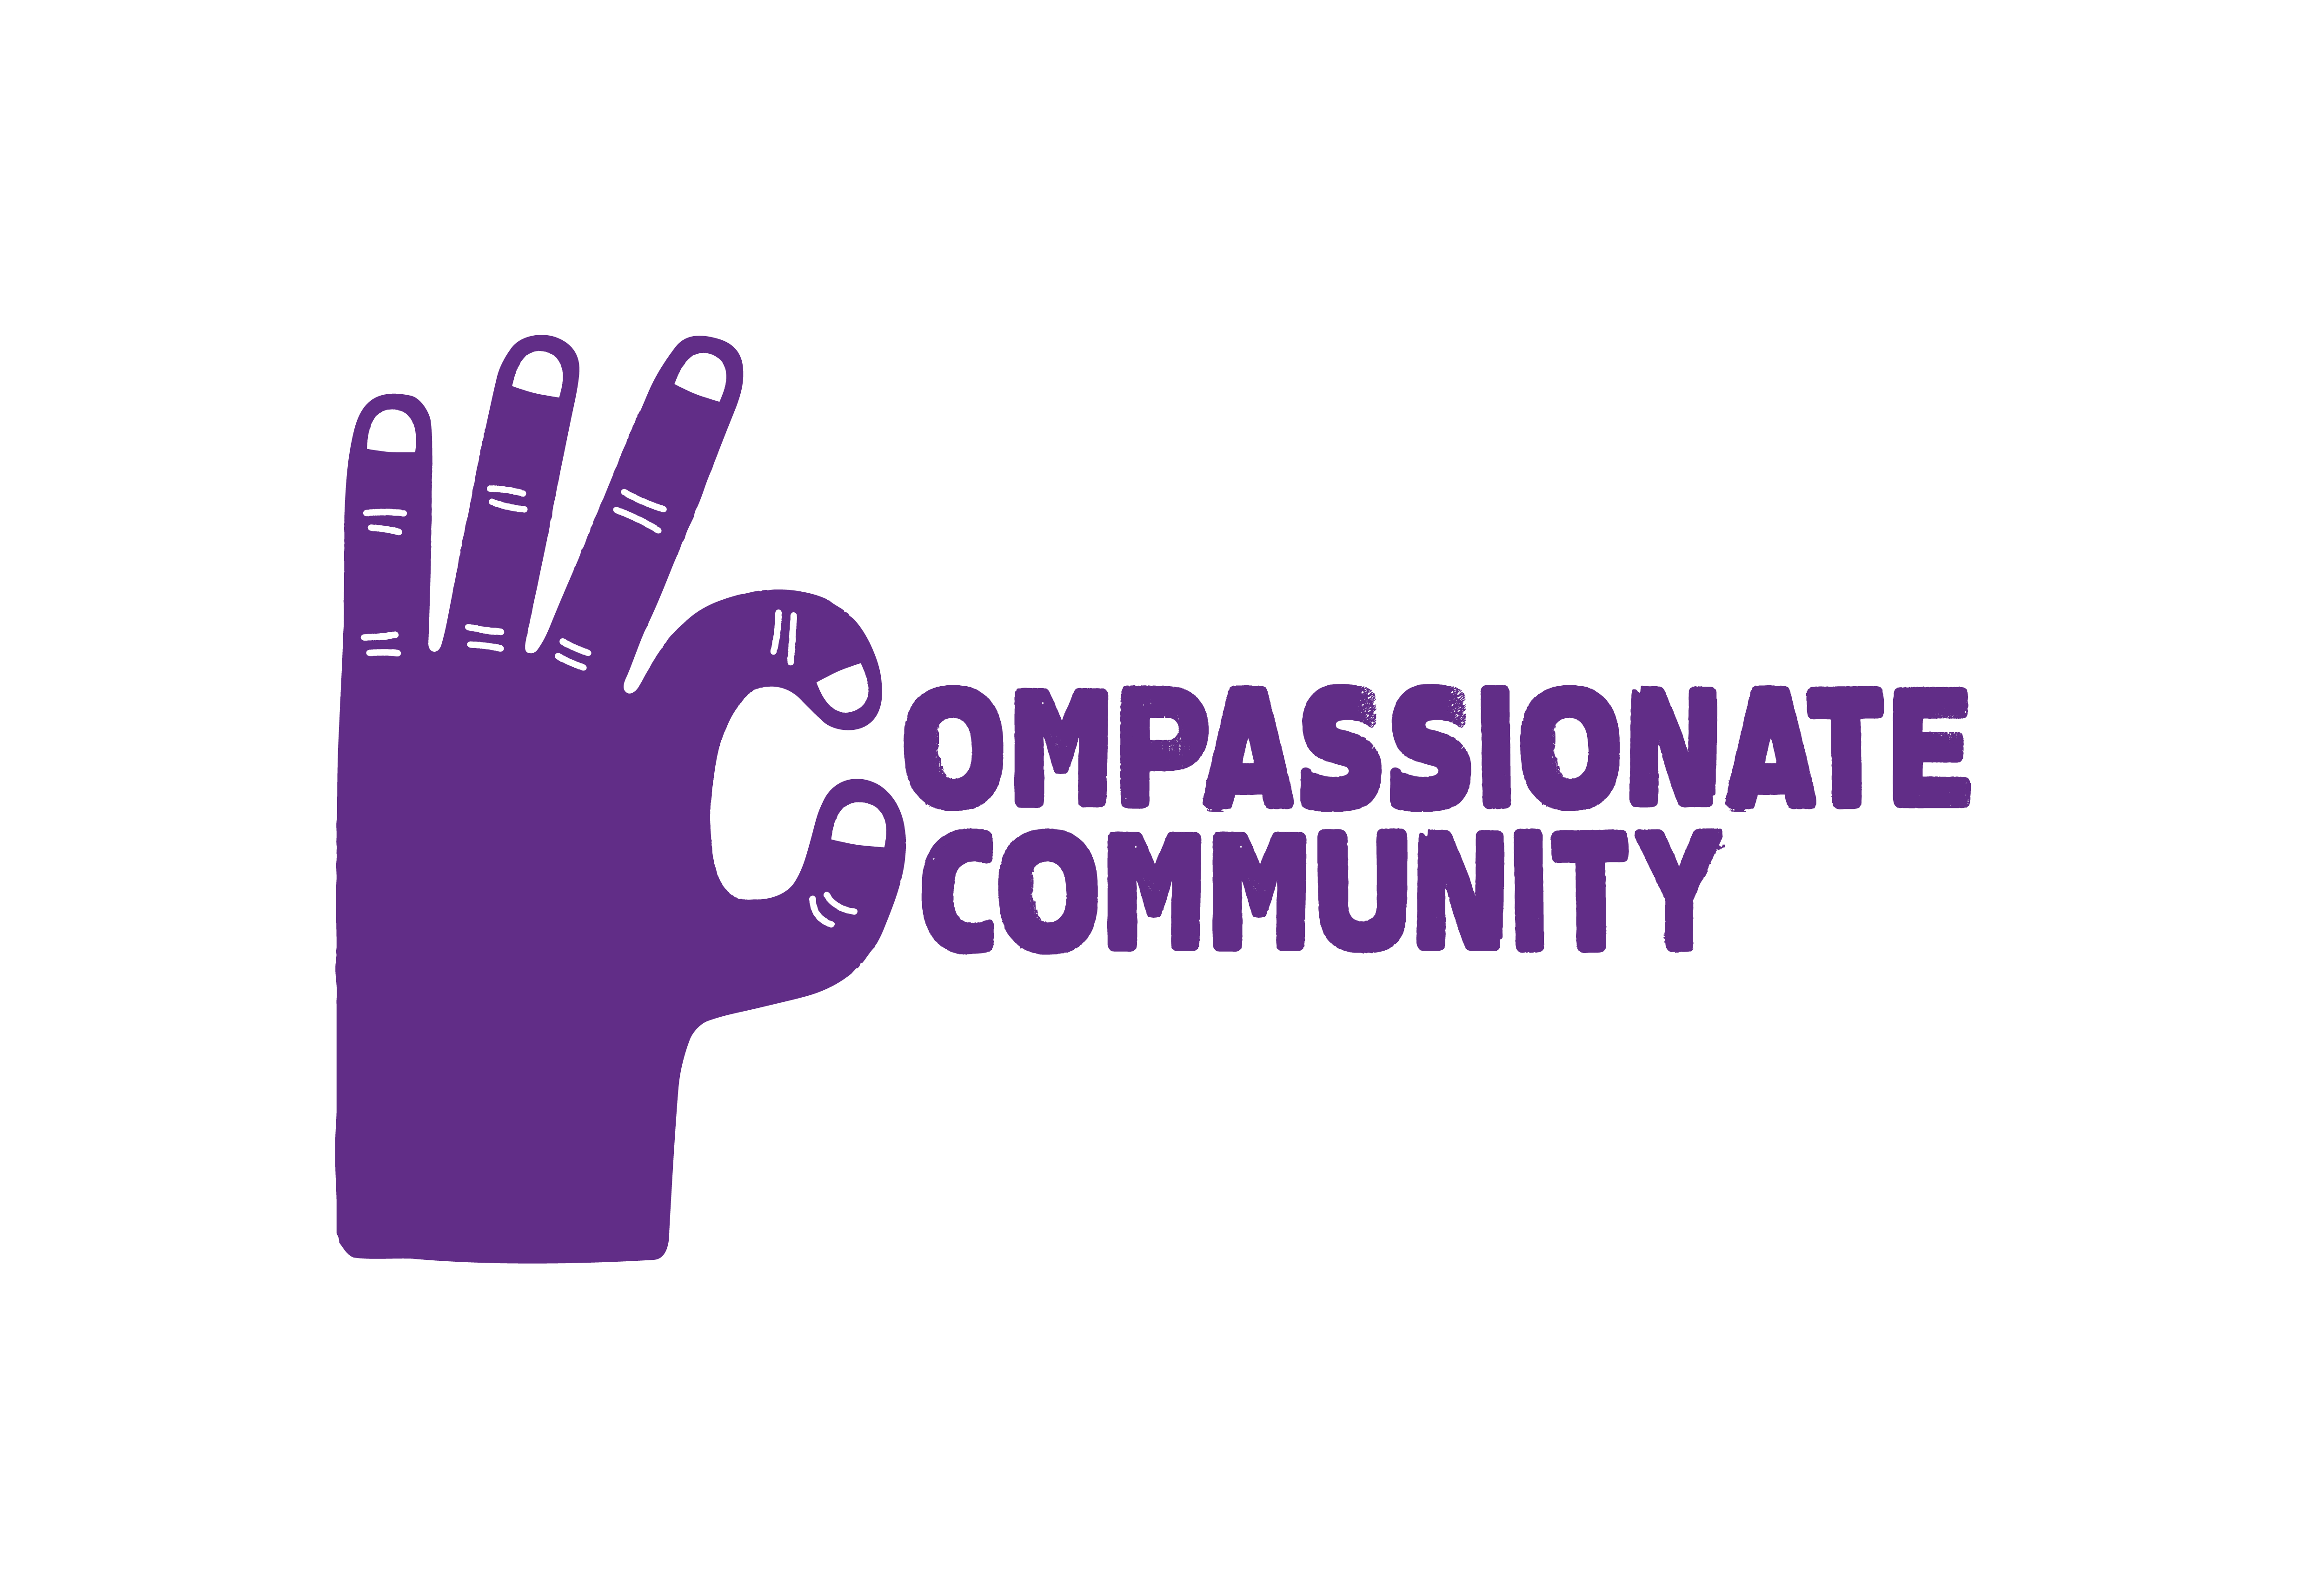

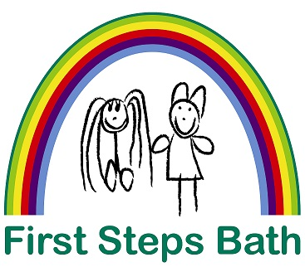

I would like to donate £…… each month to First Steps Bath to help give
local young children the best start in their early years
STANDING ORDER MANDATE - INSTRUCTION TO YOUR BANK OR BUILDING SOCIETY

To: The Manager |  |  |  | Bank/Building Society
Address
 |  |  | Postcode

Account Number |  |  | Sort Code
Account Name

Monthly donations to start with the first payment on …../..…/20.... and thereafter until further notice

Please pay the above amount to: Nat West Bank plc, First Steps Bath
Account number: 50871722 Sort code: 60-02-05
Payment reference: Donor’s surname

Title |  |  | First Name |  |  | Surname
Address
 |  |  |  |  |  |  |  | Postcode
Telephone |  |  |  |  | E mail
Signature

Gift Aid Declaration
Increase the value of your gift at no extra cost to you

Please treat the enclosed gift and any donations that I have made in the past four years and that I will make in the future to First Steps Bath as Gift Aid donations. I am a UK taxpayer and understand that if I pay less Income Tax and/or Capital Gains Tax than the amount of Gift Aid claimed on all my donations in that tax year, it is my responsibility to pay any difference.

Signature: …………………………………………................................................. Date: …......................................

Gift Aid is reclaimed by First Steps Bath from the tax you pay for the current tax year. Your address is needed to identify you as a current UK taxpayer.
Please notify First Steps Bath on info@firststepsbath.org.uk or 01225 444791 if you:
want to cancel this declaration
change your name or home address
no longer pay sufficient tax on your income and/or capital gains

Your support helps young children in Bath who are at risk of being disadvantaged by poverty and their family circumstances, and we’d love to keep you updated with our newsletters, activities and appeals by email. If you are happy to be contacted by email, please let us know your email address below:
………………………………………………………………………………………………………………………………...

If you would rather not hear from First Steps Bath by email, we would like to thank and keep you updated by post but if you would prefer not to hear from us this way, please tick here

First Steps Bath will always store your personal details securely. We will use them to communicate with you in the way(s) that you have agreed to. We will only share your information if required to do so by law. For full details, please see the Privacy Policy at www.firststepsbath.org.uk/upload/confidentiality-and-privacy-policy or contact us on 01225 444791 or info@firststepsbath.org.uk.

Please return your completed form to First Steps Bath, Woodhouse Road, Twerton, Bath BA2 1SY
www.firststepsbath.org.uk info@firststepsbath.org.uk
Registered Charity No. 1012690 Company No. 2656485

