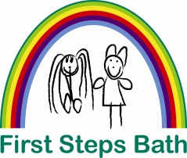

Staff Benefits Statement

- Annual leave entitlement of 24 standard days (pro rata for part time staff)
- 8 paid bank holidays (pro rata for part time staff)
- Bonus leave for long service rising up to an additional 6 days per year.
- 4 weeks paid sick leave per annum (pro rata for part time staff)
- Up to 5 days paid careers leave per annum in an emergency in order to arrange alternative care (pro rata for part time staff)
- 5% employer’s matched contribution based pension scheme
- Tax and NI free childcare on-site childcare or the use of a salary sacrifice childcare voucher scheme
- Staff receive a half price discount for two separate weeks of childcare when their child is absent on holiday
- Minimum of 3 training days per annum
- Study support time, paid time to attend day release courses is currently granted at 50% of the required college time, up to a maximum of one half day (pro-rata) each week for the anticipated length of the course, during term times only.
- Pay scale progression through satisfactory appraisal after one years’ service within pay grade
- Free Uniform (4 items full time)
- Free Disclosure and Barring Service check and Annual update.
- A half day rest day (pro-rata for part time staff) reward for no sickness in the previous quarter.
- Free Paediatric First Aid Training
- Children of staff receive a ‘priority’ childcare place to support staff to return to work.
- Continuing Professional Development Opportunities
- Career Progression Opportunities
- Half day toil for 83% attendance at staff meetings (10 out of 12)

